COOK ELEMENTARY SCHOOL


School Procedures & Family Handbook
2025-2026

9802 Woodbury Ave.
Garden Grove, CA 92844
Tel: (714)663-6251 Fax: (714)663-6087
www.ggusd.us/Cook







COOK ELEMENTARY SCHOOL

Garden Grove Unified School District has developed an educational program that is consistent with research and effective practice. Cook Elementary School provides a caring and challenging school environment that seeks to develop strong academic skills, discover special interests, and promote activities for personal and social growth.

The Cook School Procedures & Family Handbook is designed to assist students and parents/guardians so they can have an enjoyable school year. Each part of the handbook provides the information necessary to enhance the effectiveness of the school environment. The handbook also includes policies and procedures adopted by the Board of Education as well as those practices unique to our school campus. We encourage parents/guardians and students to read the handbook and discuss the school policies throughout the school year.

PARENT RIGHTS AND RESPONSIBILITIES

All parents and guardians are required to receive an annual copy of the Garden Grove Unified School District Student Parent Handbook which is available online through your parent portal account. The school keeps a signed copy of the data confirmation page that indicates you have received this information.

SCHOOL HOURS AND ATTENDANCE

SCHOOL HOURS
- Daily Schedule on Mondays, Tuesdays, Thursdays, and Fridays: 8:05 am-2:25 pm
- Early Release Wednesdays: 8:05 am-1:35 pm
- Minimum Day (Conference Week): 8:05 am-1:05 pm
- Last Day of School 8:05 am-12:15pm

ATTENDANCE
Regular and punctual school attendance is vital to a student's success in school. Daily attendance at school is one of the greatest contributing factors to increased academic achievement. Students are required by law and Education Code 48260 to attend school regularly and on time.

Regular school attendance is important for every student for the following reasons:

- Students need to be in class to receive daily instruction from the teacher.
- The teaching-learning process builds on lessons previously taught.
- Lessons often involve hands-on activities, which cannot be duplicated with paper and pencil assignments outside of class.
- Students develop the habits of good attendance and punctuality for future endeavors.
- School funding is dependent on school attendance.

ABSENCES
Excused absences are reserved for absences related to student illness, medical, dental, or optometry appointments, or attendance at a funeral service for a family member. If a student is out ill for three or more consecutive days, the school may request a doctor’s note to verify the absence.

Unexcused/Excessive Absences are absences for any reason other than those listed as an excused absence, including vacation and travel. Three or more unexcused absences in a school year will be considered excessive. Excessive absences and/or tardies, will result in action by the teachers, the principal, and/or the District Attendance Worker as necessary. Problems that persist are referred to the School Attendance and Review Board (S.A.R.B.).

REPORTING AN ABSENCE
When your child is absent, please call the school office no later than 8:30 a.m. on the day of the absence. If the absence is not verified by telephone, the student is required to bring a note, signed by a parent, which includes the reason for absence, name and grade. Absences not verified by the second morning after the student returns will require a phone call to the parent from the school office.

RETURNING TO SCHOOL AFTER AN ABSENCE
Students should not attend school when they are ill. Students must be fever-free for 24 hours before returning to school. It is the parent’s responsibility to pick up their student in a timely manner if he/she/they are being sent home from school due to illness. The student must be checked out of the school by an authorized adult using the sign-out sheet in the front office. Students are not allowed to leave on their own under any circumstances.

TARDIES
Students are expected to be on time to school each day. School begins at 8:05 a.m. Students who are late to school miss valuable class instruction and create a disruption to the learning of others with a late entrance to class.

The school bell rings at 8:05am. Students should be lined up in an orderly manner with their class when the bell rings. Any student who arrives on campus after 8:05am must enter the school through the front office to receive a tardy slip before going to their classroom.

Excused Tardies are permitted for the following reasons:
- Medical or dental appointments for the student only (must return with a note)
- Sick/not feeling well
- Immediate family member funeral
- Court appearance
- Religious observance

Unexcused/Excessive Tardies are tardies for any reason other than those listed as an excused tardy.

EXCESSIVE TARDIES
Parents and/or guardians of students with excessive tardies will be contacted by the teacher or principal for a meeting and may be referred to the School Attendance and Review Board (S.A.R.B.). A written note verifying illness or doctor's appointment will be an excused tardy

ARRIVAL/DISMISSAL PROCEDURES

ARRIVAL
Students are to arrive at school no more than 20 minutes prior to their starting time which is 7:45am unless they participate in the school breakfast program or a before-school intervention class. If they are participating in the school breakfast program, students should arrive no earlier than 7:40 a.m. and line up at the gate next to the school MPR. Please adhere to these times since adult supervision will only be provided during the times listed. Students that arrive after 8:05am must enter the school through the front office to receive a tardy slip before going to their classroom.

DISMISSAL
All students should be picked up at the correct dismissal time each day. Unfortunately, we do not have the facilities to watch students after dismissal time. If students are walking or riding a bike to school, your child should go directly home. If you will be picking them up, please make every effort to be on time.

EARLY PICK-UP
When it is necessary to withdraw your child from class for an appointment, please notify the teacher by email, written note, phone call, or ParentSquare message in advance. Unexpected classroom withdrawals can be disruptive to classroom instruction. Please check in with the front office to sign your child out when leaving and sign the student back in when/if returning. Any parent or adult picking up a student must be designated on the emergency card.

SAFETY TO AND FROM SCHOOL
Please speak with your child about going straight to school in the morning and straight home after school. Be sure that you inform the front office immediately if there are any issues with strangers, etc., on the way to and from school.

RIDING A BICYCLE TO SCHOOL
Students in grades 3-6 may ride bikes to school with parent permission. There is a bike rack located next to the school MPR. In order to prevent thefts, bike locks are required. Bikes should be in good repair and free of any inappropriate logos, stickers, or wording. Students are required to follow all traffic laws and safety regulations when traveling to and from school. All students are required to wear a helmet when riding their bicycles to and from school and must go directly home. Cook Elementary School is not responsible for damage or theft of any bicycle brought to school.

PARKING LOT PROCEDURES

It is always our aim to make Cook Elementary School a safe place for our students. To ensure that safety, we have developed a system of traffic flow which, if followed, will help all children arrive and depart school safely and efficiently. Please take some time to review our parking lot procedures and adhere to all the rules throughout the school year.

TK & KINDERGARTEN PICK-UP/DROP-OFF EXPECTATIONS:

- Please allow for extra time during pick-up and drop-off especially in the beginning of the school year.
- TK & K students can be dropped off no earlier than 7:45am. No supervision will be available until this time.
- Students should be picked up at 2:25pm on Mondays, Tuesdays, Thursdays, & Fridays. On Wednesdays, dismissal time is at 1:35pm.
- You may park in the Kindergarten lot and walk your child to and from the front gate each day or use street parking. Please be sure to park legally to avoid being cited by GGPD.
- Please use the sidewalk closest to the street to walk your child to and from the school front gate.
- Please give your hugs and good-byes prior to your child entering the school gates in the mornings. For safety reasons, parents and/or guardians will not be permitted on campus.
- Staff members will be available to guide students to the right place. Please have your child wear their sign for the first week of school with their name, teacher, and room number. You will receive this sign at TK/Kindergarten Orientation prior to the first day of school.
- If your TK or K student has older siblings, you can use the car line to drop off and pick up your child if they are able to buckle themselves safely into their car seat or booster seat.

Please refer to the map below for how to enter and exit the car line during arrival and dismissal.

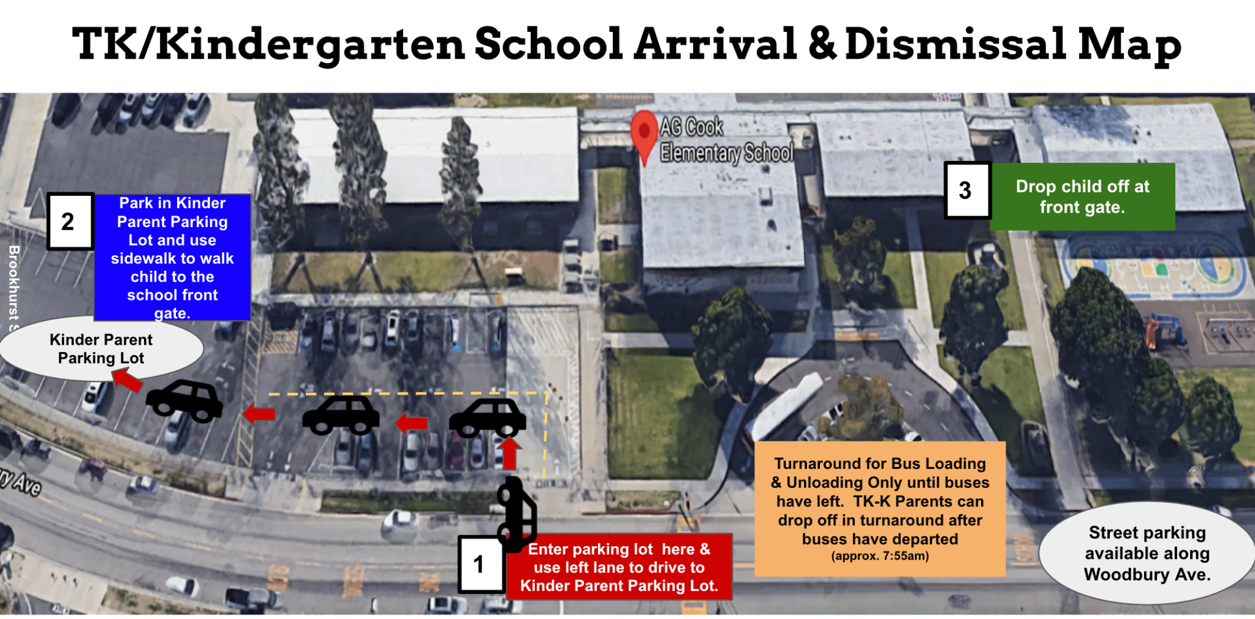

GRADES 1-6 PICK-UP/DROP-OFF EXPECTATIONS:

- Please allow for extra time during pick-up and drop-off especially in the beginning of the
school year.
- Students can be dropped off no earlier than 7:45am. No supervision will be available until this
time.
- Students should be picked up at 2:25pm on Mondays, Tuesdays, Thursdays, & Fridays. On
Wednesdays, dismissal time is at 1:35pm.
- At arrival time, please make sure your child is ready to quickly exit the vehicle--their
backpacks and lunches should be easily accessible. Please do not put any of their school belongings in the trunk. This will slow down the arrival process for all.
- Once your child exits, please wait to be instructed to pull out by the teacher on duty for
everyone’s safety.
- Please remain in your car at all times. There is no need to exit your vehicle unless you are a TK
or Kindergarten parent parking to pick your child up at the Kindergarten yard.
- Please be sure to check for other vehicles when exiting the parking lot.
- Only right turns are permitted when exiting our parking lot for everyone’s safety.
- During dismissal, please place a sign in your car with your child’s grade level and first and last
name. This is how we will know who to call and come to your car.

Please refer to the map below for how to enter and exit the car line during arrival and dismissal.

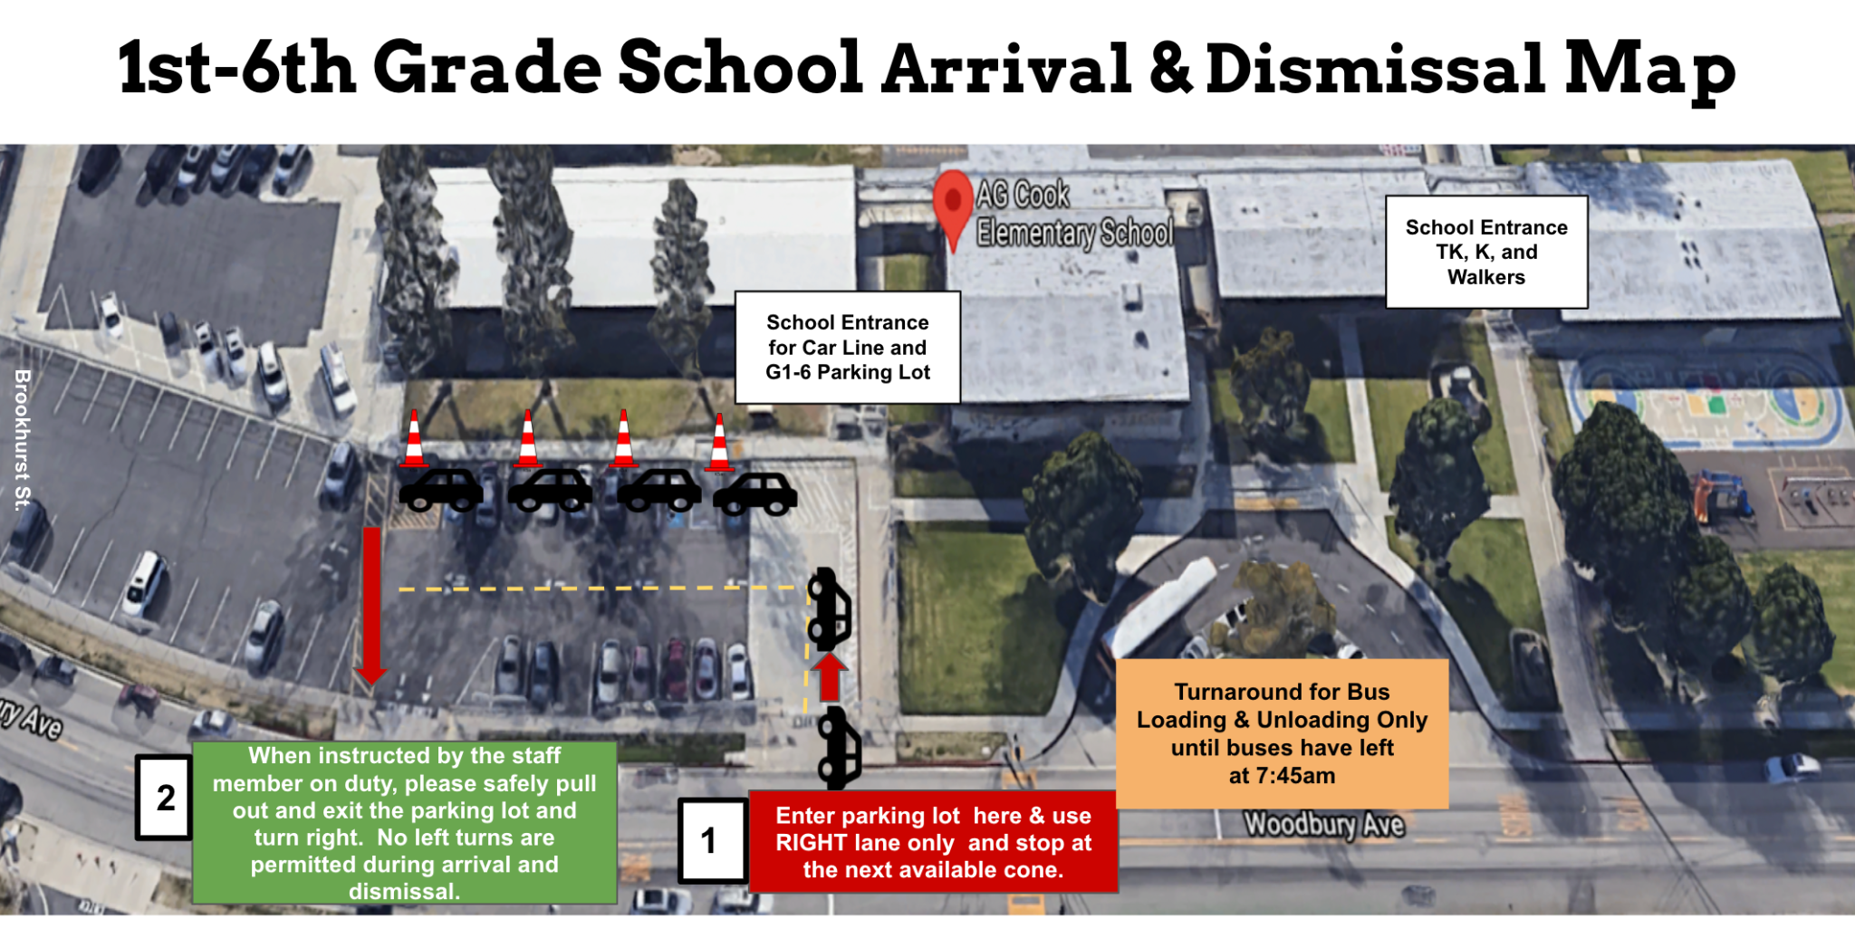

CAR LINE PLACARD

If you are using the car line to drop off and pick up your child, please use the car line placard provided by the school. If you do not have it, please make a sign that clearly and boldly displays your child(ren)’s name and grade on the right-hand side of your windshield. A staff member will call your student’s name as you enter the main parking lot. You will receive the placard at the beginning of the school year and extras can be obtained in the front office.

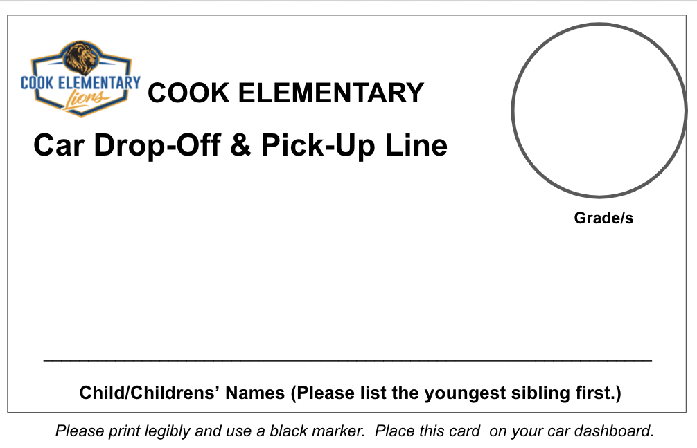

PARKING LOT SAFETY

If you are walking to pick up your child or parking and then walking to the school gate to pick up your child, proceed to the gate next to the TK/Kindergarten Building if your child is in TK or Kindergarten. For students in grades 1-6, proceed to the gate next to the school MPR. Students will be dismissed from that gate by a staff member.

If you drive and pick up your child in grades 1-6, please use our car pick-up line in the main parking lot. As you enter the parking lot, be sure your car line placard is clearly displayed in your front windshield on the right-hand side. A staff member will call for your child to report to the car line to wait for you. Please discuss with your child to be attentive and look for your car. Pull all the way up in the car line and then your child can safely enter your vehicle.

Please remember to drive slowly and be cautious when in the parking lot for the safety of our students and their families. Traffic at Cook Elementary School is often congested during arrival and dismissal. Please be patient and kind at all times when in our school parking lot. Students are present so please refrain from vulgar language and profane gestures. Our students’ safety is in your hands. We thank you in advance for your cooperation and understanding.

BREAKFAST, LUNCH, & SNACK TIME

Breakfast and lunch are available in the cafeteria free of charge for all Cook Elementary School students.

BREAKFAST
Breakfast is served from 7:40am-7:55am. Students will enter the school MPR building to receive their breakfast. Please be sure to have them arrive on time for breakfast so your child has enough time to eat.

LUNCH
Lunch will be served between 11:40am-1:05pm depending upon your child’s grade level. Students may also choose to bring their lunch. If your child brings lunch, milk may be purchased for 50 cents.

FORGOTTEN LUNCHES
To help limit the number of classroom interruptions, please do your best to help your child remember his/her/their lunch every day. Classroom instructional time will not be interrupted for forgotten lunches. If your child forgets his/her/their lunch, please bring it to the front office and place it on the bookcase nearest the front door. Please be sure to label your child’s lunch with their name, grade, and room number. We will ensure their lunch gets to them.

STUDENT FUNDING DATA COLLECTION FORM
All families must fill out the School Funding Data Collection Form so our school is able to participate in this free lunch and breakfast program. Please see our front office for a copy of this form if you have not already submitted one.

SNACKS
Nutritious snacks help students maintain focus and energy throughout their instructional day. Nutritious snacks are allowed to be eaten at recess. These snacks must be healthy in order to support learning. Fruit, vegetables, cheeses, crackers, raisins, and granola bars are some examples of healthy snacks. Junk food, candy, and sweet or caffeinated drinks are prohibited. These items will be confiscated and sent to the office and may be picked up by parents/guardians after school. Students can eat their snacks at the shaded lunch structure on the playground.

SCHOOL WIDE BEHAVIOR EXPECTATIONS (SCHOOL RULES)

Cook Elementary School strongly believes in creating a safe, welcoming, and inclusive school climate that reinforces positive behavior to help educate, support, and prepare our students to be innovative, empathetic, and productive members of society. This is why we use positive behavioral interventions and supports (PBIS) on our school campus. As a PBIS School, we focus on teaching students about the behavior expectations at school, practicing these behaviors, and positively reinforcing good behavior. The focus of PBIS is prevention not punishment. Below is the behavior matrix that students will learn during the first two weeks of school. Please review this with your child throughout the school year:

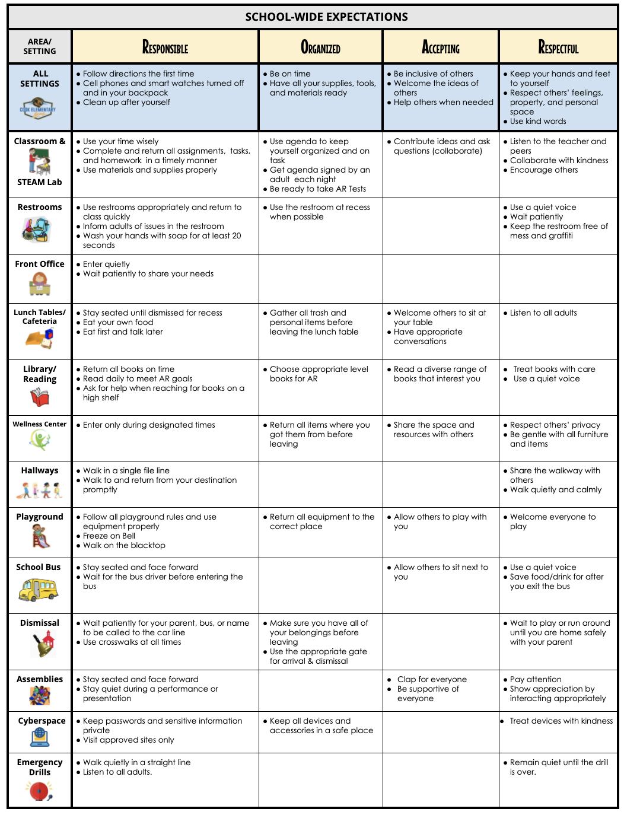

ACKNOWLEDGEMENT SYSTEM

All students are expected to be Responsible, Organized, Accepting, and Respectful (R.O.A.R.). Students that exemplify these traits will be awarded “Lion Loot” that can be redeemed for weekly raffles and monthly student experiences.

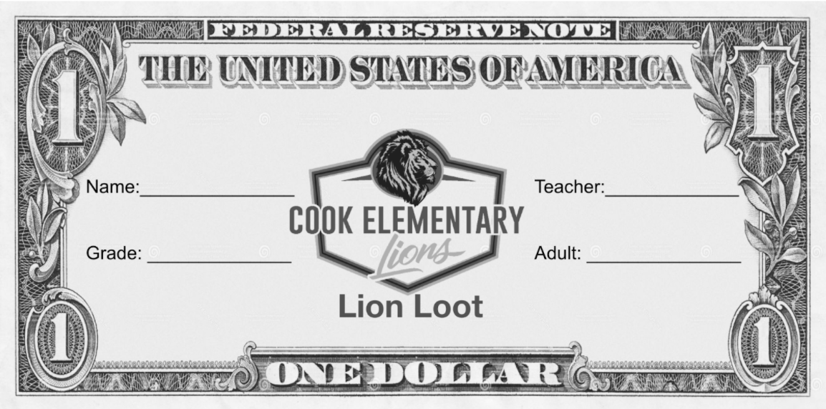

HOW IT WORKS:

WEEKLY
- Students place their Lion Loot in grade level bins located in the cafeteria or TK/K playground.
- The Lion Loot is gathered each Friday for a drawing by grade level.
- Names are pulled from each grade level bucket to do the Prize Drop for a prize.
- The Lion Loot is then saved for future quarterly drawings and the year- end celebration
assembly.

MONTHLY
Student of the Month will also focus on one PBIS trait each month (Responsible, Accepting, Organized, and Respectful).

EACH TRIMESTER
Students can choose to save up their Lion Loot and turn it in for special student experiences.

YEARLY
At the end of each school year, there is a school wide PBIS Celebration and all Lion Loot is emptied into a large container for a school wide raffle celebration. Lion Loot is pulled from the large container until all prizes have been awarded.

To put this yearly event on, we invite parents and/or guardians to donate gift cards and prizes to make this celebration as fun and rewarding for students as possible. If you would like to donate to our PBIS Celebration, you can drop off all donations to our front office. Lion loot must be used in the school year in which it is earned.

CONSEQUENCE SYSTEM

Students who need extra support in the area of behavior are provided additional guidance through the use of verbal reminders and written reminders, our behavior referral system (minor and major referrals), principal conference meetings, behavior charts, incentives, counseling support, and parent communication. Dangerous or violent behavior will fall under the scope of the CA Ed Code and may require suspension or expulsion based on state law guidelines. Hate speech may also fall under this scope.

MINOR REFERRALS: Minor infractions will be handled in the classroom with the teacher. Teachers may issue a minor referral to students not adhering to the behavior expectations. These will be sent home for your signature so that you are aware.

MAJOR REFERRALS: Major violations of our school wide behavior expectations will result in an automatic major referral that is handled by the school principal. Students may also receive a major referral for receiving three minor referrals for the same infraction. All major referrals will be accompanied by the principal contacting the parent for a conference to address the behavioral concerns.

NO PLACE FOR HATE

Cook Elementary School is a No Place for Hate school. This means that we strive to create a school climate that is inclusive and safe for all students. Bullying, cyberbullying, racial slurs, and insults are seen as major violations of our school wide behavior expectations and will be dealt with accordingly. Please speak to your child about the importance of using kind words on campus and the impact that word can have on others. Together, we can make Cook no place for hate.

STUDENT RECOGNITION

STUDENT AWARDS
Academic achievement and improvement are an important goal at Cook Elementary School. Outstanding performance in the following areas are recognized in all grade levels:

- Responsibility for Behavior (5 Citizenship Awards per class)
- Responsibility for Learning (5 Growth Mindset Awards per class)
- Meeting Accelerated Reading Goal (AR Awards for all students who reach their goal)
- ROAR Award (Up to 5 Teacher Choice Awards per class)

Each trimester, we will hold Trimester Awards Assemblies to recognize students’ academic and behavioral effort and achievement. Invitations will be sent home to the families of students that will receive an award prior to each Trimester Award Assembly.

PARENT COMMUNICATION AND INVOLVEMENT

PARENT COMMUNICATION
Teachers may communicate with parents and/or guardians about student progress in a variety of ways (i.e., individual parent conferences, phone calls, communication folders, student agendas, notes, progress reports, ParentSquare messages, emails, report cards). In addition, Parent Conference Week will be held in the fall (highly recommended) and spring (optional). If you would like to talk with your child's teacher, please call, write, email, or send a ParentSquare message to them. We are here to support you and your child so reach out if you need anything.

The school will also send weekly ParentSquare newsletters each week to keep you informed of important information about the school. Please sign up for ParentSquare so you receive this newsletter each week.

OPEN COMMUNICATION POLICY
If you have a question or concern, please be sure to consult with your child's teacher first. If there continues to be a concern, please share it with the site administrator and we can work together to try to resolve it.

GRADING SYSTEM/REPORT CARDS
Students are evaluated each trimester with a report card to parents detailing student progress toward California State Standards. Fall report cards will be explained during Fall Conferences and parents will have the option of attending a Spring Conference to explain spring report cards. Otherwise, spring report cards will be sent home. At the end of the school year, your child’s final report card will be sent home with them on the last day of school.

PARENT COMMUNICATION FOLDERS AND STUDENT AGENDAS

All Cook students are given a blue communication folder or “Wednesday Folder” that is used as a parent communication device. One pocket is designated "Keep Home" and the other is "Send Back". These folders are sent home every Wednesday and are due back to school on Thursday with a parent signature.

Students in 2nd through 6th grade will also be given a student agenda that will be used for the year. The first one is free (paid for by the PTO). If lost or stolen, it must be replaced at cost to the student. All 2nd -6th grade students will be using the agenda system to keep them organized. Parents and/or guardians should review the agenda nightly for student homework assignments and any teacher notes or comments.

HOMEWORK
The goal of homework is to support learning and develop student self-discipline, responsibility, and the ability to study independently. Typically, students will spend an average 30-60 minutes per night on homework. In addition to daily homework, teachers may assign book reports, projects, and research assignments.

The staff recommends a daily study time for homework completion. This study place at home should be free of distractions. In this way, students will learn that there is always a set time for studying and good home study habits can be developed.

PARENT ORGANIZATIONS AND COMMITTEES (VOLUNTEER OPPORTUNITIES)
Parent organizations and committees provide valuable suggestions and support to improve our school and enhance educational programs. School effectiveness is positively impacted by frequent parent participation. Parent meetings are publicized by the school regularly utilizing the Parent Square message system and flyers. Parents and/or guardians also have the opportunity to participate at our quarterly Cook parent meetings or as an elected representative on our School Site Council and/or English Language Advisory Committee. All parents and/or guardians are strongly encouraged to volunteer for one or more of the numerous opportunities at Cook.

In addition, the Cook Parent-Teacher Organization (Cook PTO) is always looking for volunteers to help with the many community events they put on throughout the school year. Please be sure to check the weekly ParentSquare Newsletter to find out how to sign up to be a Cook PTO volunteer.

PARENTS AND VISITORS
All parents and visitors to Cook Elementary School are required to sign in and out of our school office by using the office log book. Please use the front office door to enter and exit the school. We appreciate your cooperation and understanding as it is necessary for us to be aware of all individuals on our campus at all times.

HOW PARENTS CAN HELP
At School | At Home
- Volunteer for School Site Council (SSC)  - Volunteer for English Language  - Acquisition Committee (ELAC)  - Volunteer for our Parent Teacher  Organization (PTO) Events:  - PTO Movie Nights  - Cultural Celebrations  - Trunk-or-Treat  - PTO Photos with Santa  - Morning Arrival Greeters  - Classroom Volunteer (at teacher’s  discretion)  - Classroom events/celebrations | - Read to and with your child nightly  - Check homework and student agenda nightly  - Maintain positive communication with teacher by note, phone, email, or ParentSquare  - Promote student independence  - Ask for teacher clarification and input if you have a concern  - Provide a quiet, distraction-free study space
PARENT VOLUNTEER PROCEDURES
All parent volunteers are required to fill out paperwork with the front office prior to their first day of volunteering. A negative TB test and proof of vaccination must be provided. Please contact the front office for more information.

When parents are invited by the teacher to act as volunteer at the school, the following procedures should be followed:
- Please sign in and pick up a visitor’s badge in the front office each time you are on
campus.
- Encourage your child to continue what he/she/they are doing when you come into the
classroom.
- Respect confidentiality and refrain from discussing students in the classroom with
others.
- Younger children must be left at home when you are helping in the classroom or office.
- Student encouragement is welcomed but please allow students to do their own work
and gain independence.
- Please exit through the front office and return your badge before leaving. Leave all
gates locked and latched when you leave.
SAFETY

The safety and well-being of all students is a priority at Cook. The staff and administration strive to maintain a safe and secure campus that focuses on the personal safety of each student. We encourage parents and/or guardians to review safe and appropriate behaviors with their children using the behavior expectations discussed earlier in this handbook.

EMERGENCY CONTACT INFORMATION
Parents and/or guardians are required to keep all contact information on Aeries Parent Portal and on the School Office Emergency Cards current. Please be sure to keep the office informed of any new home, work, or cell phone numbers or emails. You may also want to update this information on the Aeries Parent Portal as well. If you have a new address, you will need to bring in proof of residence to the front office. Without appropriate contact information, we will have to resort to calling the authorities in cases of illness or emergencies if the contact information is not accurate.

CLOSED CAMPUS
In order to ensure the safety and wellbeing of students and staff, we have a closed campus between the hours of 7:00 a.m. until 4:30 p.m. There is no after-school supervision during closed campus hours unless your child is a registered Boys and Girls Club member. California State Law requires that all persons entering campus or wishing to visit classrooms must register at the school office. Please first come to the office so that we can assist you. This policy is designed to protect students and staff. For safety reasons, parents and/or guardians are not permitted past the school gate during school hours. If you would like to visit the campus, we ask that you contact the front office to schedule a time. When you arrive, please check in with the office first to sign in so we are aware of all visitors on campus at all times.

EMERGENCY SAFETY PLANS
The school has a plan to ensure the safety of students during any kind of emergency. This plan is available in each classroom, from the school office, and will be shared at the first Cook parent meeting of the school year. Safety drills are conducted regularly. Emergency equipment, supplies, and communication equipment are kept on site.

Students are trained on safety and emergency procedures and are required to follow school rules during emergency drills. Parents and/or guardians must keep the emergency card information current for the health and safety of their children.

INJURIES AND ILLNESS
If a student is injured or becomes ill while participating in any school activity, he/she must notify the teacher immediately. Staff members trained in first aid and CPR are on site and will assist students in need of basic first aid care. Parents and/or guardians will be notified should a student be injured or become ill.

School districts do not provide health and/or accident insurance. Information about low-cost insurance is available online through your parent portal account.

FOOD ALLERGIES
Please inform the office of any acute allergies your child may have so we can work together to create a safe, allergy-controlled zone for your child.

MEDICATION
Medication should be taken at home with parent supervision whenever possible. Prescriptive and non-prescriptive medication may be taken at school only under supervision of school personnel. A medication form which includes dosage instructions must be completed by the parent and the child’s physician before medication will be administered at school. These forms are available from the school office.

Students are not allowed to carry prescription or over-the-counter medication to school. Parents/guardians may provide the student medication to the school health office and will only be given by school personnel after we have the required form completed by your physician. Parents/guardians should pick up any registered medication at the end of the school year, or it will be discarded by the school.

PROHIBITED ACTIVITIES
Due to danger and noise, motorized vehicles, model aircraft, golfing, skateboards, inline skates, roller skates, or other hazardous objects or activities are strictly prohibited on school property at all times. Alcohol, smoking, and dogs are prohibited on school property at all times.

LIBRARY POLICIES & PROCEDURES

The Cook Elementary School library is a wonderful place dedicated to reading and learning. Our library is open to all students who attend the school.

EXPECTED BEHAVIORS
- Quiet library voices: no raised voices or yelling
- Quiet library feet: no running, jumping, climbing, or disruptive behavior
- Respect for library books and furnishings
- Respect for all adults and students in the library

CHECKING OUT LIBRARY BOOKS
Students will be able to check out books from our school library during their class’ regular weekly library time. The number of books checked out is dependent on the discretion of the teacher and the librarian.

All students and parents are required to fill out the Library Policies and Procedures form prior to checking out books from the library. This form is sent home with each student on the first day of school.

Students must show responsibility in caring for and returning library books on time. Library books are checked out for one week at a time. Students can keep a book for a second week but only if they bring the library book back on time and renew it with the librarian. Students who show a repeated lack of responsibility may have their library privileges suspended at the discretion of the librarian and principal. If a book is lost or damaged, the replacement or repair cost must be paid before the child can check out any additional books. The librarian will provide a statement with the value of the book(s).

TEXTBOOKS, SCHOOL PROPERTY & TECHNOLOGY

TEXTBOOKS AND SCHOOL PROPERTY
Students are responsible to pay for the replacement of damaged and/or lost school textbooks, library books, and school property. Parents and/or guardians are liable for willful damage or loss of school property.

TECHNOLOGY
All students are expected to follow the detailed GGUSD Technology policy and contract for their security and safety. They may only visit approved sites and may never share password information. Violation of the technology policies may result in removal of technology privileges at school.

Parents and/or guardians are highly encouraged to monitor at-home student technology use including but not limited to the use of apps such as Tic Tok, Discord, SnapChat, Roblox, Minecraft, Fortnite, and texting. Many interpersonal conflicts between students start on these applications at home and can affect their relationships when at school. Please be proactive in ensuring appropriate student dialogue when your child is using technology at home.

Students in need of a device or a hotspot for school use only at home can check them out provided they are available. Please check with the front office for availability. All technology devices must be checked out by a parent or guardian but only after all forms have been signed and returned to the front office.

CELL PHONES
Students may bring a cell phone to school; however, it must be powered off at all times during the instructional day and left inside your child’s backpack. If a student violates this rule, the cell phone will be confiscated and a parent/guardian will be contacted to pick up the device from the front office. Progressive discipline of future violations may include the cell phone being required to be stored in the front office until the end of the school day.

SMART WATCHES
Students may wear a smart watch in class; however, it must be on “SCHOOL MODE”. If a student violates this rule, the smart will be confiscated and a parent/guardian will be contacted to pick up the device from the front office. Progressive discipline of future violations may include the smart watch being required to be stored in the front office until the end of the school day.

PERSONAL DEVICES
No personal devices, such as tablets, laptops, or computers are allowed on campus since we offer district-approved devices with a firewall for safety to all students.

ADDITIONAL INFORMATION

STANDARDS OF DRESS AND GROOMING
Parents and/or guardians are encouraged to ensure that their child is dressed appropriately for all on-campus and off-campus school activities. Parents and/or guardians will be notified if their child violates the dress code. Students may be required to change their clothing. Violations of dress code include:

- Any clothing that distracts from classroom instructions such as items that advertise alcohol, drugs, or vulgar behavior/language.
- Sandals of any kind. For student safety, only closed toe/closed heel shoes are allowed on campus.
- No short-shorts or any revealing clothing; only decency and modesty are appropriate at school.
- Scented products should remain in student backpacks and only be applied to the student who brought it. No products should be shared or applied in a way that it gets on any other individual.

CAMPUS CLEANLINESS
The school is our shared environment. Our school's reputation in the neighborhood and with visitors is largely determined by our campus appearance. All students are expected to help keep the campus clean. Parents and/or guardians are encouraged to promote campus cleanliness as well.

LOST AND FOUND
Students are to assume responsibility for loss or damage to personal property. School personnel attempt to provide for the protection of property, but the school is not responsible for the replacement of personal items. Each student is encouraged to write his/her name on all personal belongings. Large sums of cash should never be brought to school. Students are encouraged to return items that are found to the lost and found in the office.

BIRTHDAY/CLASSROOM CELEBRATIONS
As a school, our first priority is to ensure all students learn, therefore, instructional time is protected time. But we also understand that birthdays are very special to children. Birthday celebrations will be permitted at the discretion of the teacher and only at the end of the instructional day. If you choose to send something to school with your child, please only send a small, healthy treat or a goodie bag with age-appropriate items. These will be handed out at the end of the day. Cupcakes, cakes, etc. are not allowed.

For the safety of all children, no peanut products or nut products may be brought to school to share in any classroom celebrations.

NOTIFICATION OF MOVE
Please let the front office know ahead of time if you are moving. We can put together the papers you will need to enroll in your new school. All textbooks, workbooks, district-issued devices (iPad, Chromebook, chargers, etc.) and library books must be returned before leaving on your child’s last day at Cook.

Cook Elementary
School Procedures & Family Handbook
Parent/Guardian Acknowledgement

Dear Parent and/or Guardian,

It is very important that you actively review the contents of the Cook Elementary School Procedures & Family Handbook with your child. Once you have done so, please sign this form and return it to the school to verify that you have read and reviewed the handbook with your child. Your signature does not necessarily indicate approval of any section of the Parent-Student Handbook, but merely indicates you have received the information.

----------------------------------------------------------------------------------------------------

I have read and understand the information presented in the
Cook Elementary School Handbook

Parent/Guardian Signature Date

Student Name (Print Clearly) Date

Student’s Teacher Grade Rm #

